**IOT BASED VERMICOMPOSTING**

**ABSTRACT**

|  |  |  |  |
| --- | --- | --- | --- |
| **S.NO** | **CHAPTER** | **TOPICS** | **PAGES** |
| 1 | 1 | Introduction | 2 |
|  | 1.1 | objectives | 3 |
| 2 | 2 | Design And Fabrication | 3 |
|  | 2.1 | Electrical Elemants and Sensors | 3-5 |
|  | 2.2 | Hardware Diagram | 6 |
|  | 2.3 | Electrical Circuit | 7 |
|  | 2.4 | Output and IOT Diagram | 8 |
| 3 | 3 | Programming And Iot Interaction | 9 |

**INDEX**

**CHAPTER 1**

**INTRODUCTION**

Vermicomposting is a low-cost technology that naturally converts organic wastes into organic fertilizers, commonly called vermicompost, through the combined action of earthworms and mesophilic microorganisms. Vital parameters, such as moisture and temperature, must be considered in the vermicompost production to achieve optimum yield. However, manual monitoring and correction of these said parameters do not give guaranteed results. Also, the traditional process of harvesting vermicompost consumes longer time and requires more human intervention. As a solution, the proponents introduced the development of a system which monitors and corrects these vital parameters, determines the readiness of vermicompost for harvest using digital image processing, and automatically sieves the vermicompost. The system uses Arduino microcontroller, sensors, and an android phone for monitoring. To measure the system’s reliability and efficiency, the proponents conducted two setups of vermicomposting system – one controlled and the other uncontrolled. From the data gathered, the automated system surpassed the latter in terms of production time, yield quality and quantity.

* 1. **Objective**

The objective of using IoT (Internet of Things) technology in vermicomposting is to enhance the efficiency, productivity, and sustainability of the vermicomposting process. Vermicomposting is the practice of using earthworms to decompose organic waste materials, such as kitchen scraps and garden waste, into nutrient-rich compost. Integrating IoT into vermicomposting can achieve several goals:

* Monitoring Environmental Conditions: IoT sensors can be used to monitor and control environmental conditions within the vermicomposting system. This includes tracking temperature, humidity, pH levels, and oxygen levels to create and maintain optimal

conditions for the earthworms and microorganisms involved in the decomposition process.

* Remote Monitoring and Control: IoT technology enables remote monitoring and control of the vermicomposting system. This allows operators to make real-time adjustments to environmental conditions and feeding schedules, even from a distance, ensuring the worms are thriving and the process is efficient.

**CHAPTER 2**

**DESIGN AND FABRICATION**

* 1. **Electrical Elements and Sensors**
* DS18B20 Temperature Sensor

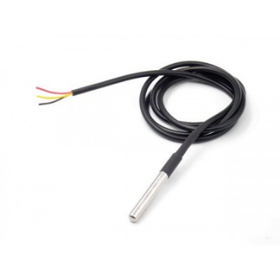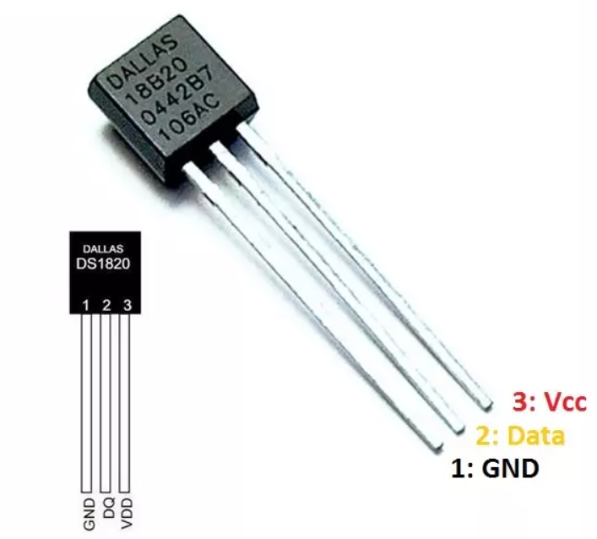

* Digital Sensor
* One-Wire Interface
* High Accuracy: ±0.5°C
* Waterproof

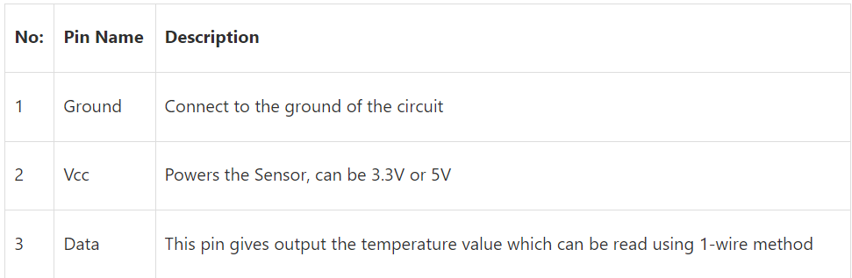

* Analog Waterproof Capacitive Soil Moisture Sensor

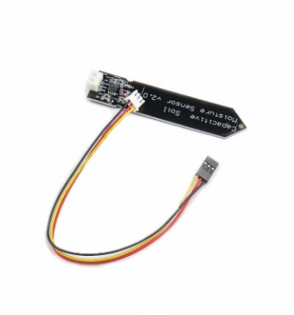

* Operating Voltage: 3.3 ~ 5.5 VDC
* Output Voltage: 0 ~ 3.0VDC
* Operating Current: 5mA
* Waterproof

A capacitive moisture sensor works by measuring the changes in capacitance caused by the changes in the dielectric. The pulse goes to the capacitor, so when the current goes through the capacitor is charging and discharging eventually and this is measure with timer. When the dielectric changes (water) the capacitance also changes, so the amount of time it takes to charge and discharge also changes which is then measured by the timer. This all embedded in the sss timer chip of sensor.

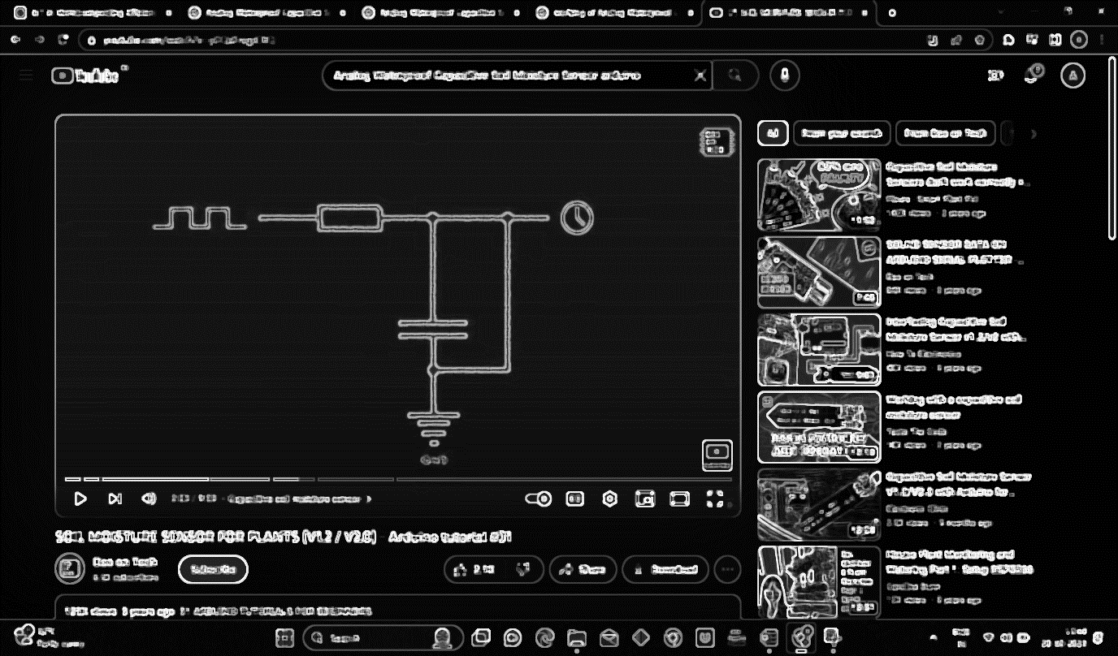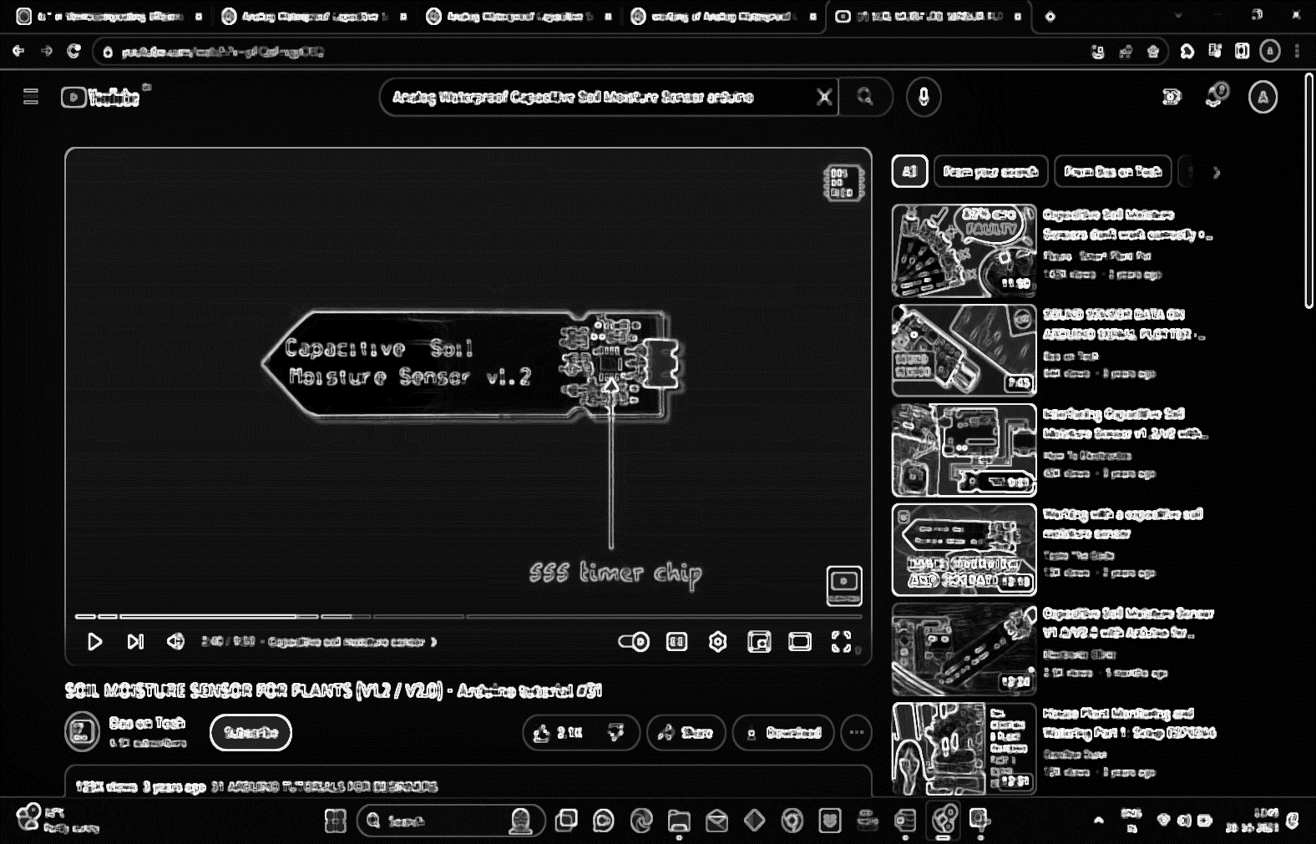

* Analog pH Sensor

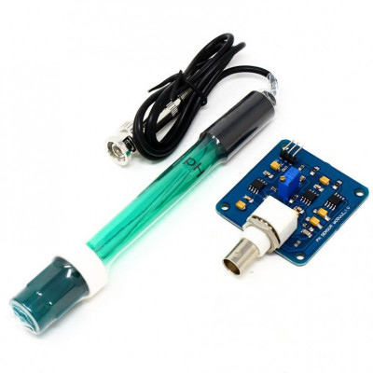

* Module Power 5.00V
* pH Measuring Range 0-14
* Measuring Temperature 0-60
* Accuracy ± 0.1pH 25
* Response Time 1min
* pH Sensor with BNC Connector
* waterproof

An Analog pH Sensor is a device used to measure the pH (acidity or alkalinity) of a solution. pH is a fundamental parameter in chemistry and is often used to assess the acidity or alkalinity of a liquid. Analog pH sensors provide an analog voltage or current output that corresponds to the pH value of the solution they are immersed in. Analog pH sensors work on the principle of electrochemical measurement. They use a glass electrode as the sensing element. The glass electrode contains a special pH-sensitive membrane that responds to changes in the concentration of hydrogen ions (H⁺) in the solution.

* Analog Infrared CO2 sensor SEN0220
* Operating Voltage: 4.5 ~ 5.5V DC
* Average Current: <85Ma
* Output Signal: UART/PWM/Analog output (the last two has not been developed)
* Measuring Range: 0 ~ 50000ppm
* Accuracy: ± (50ppm + 5% reading)
* Preheating Time: 3min • Response Time: T90 < 30s
* Operating Temperature: 0 ~ 50
* Operating Humidity: 0 ~ 95% RH (no condensation)
* waterproof

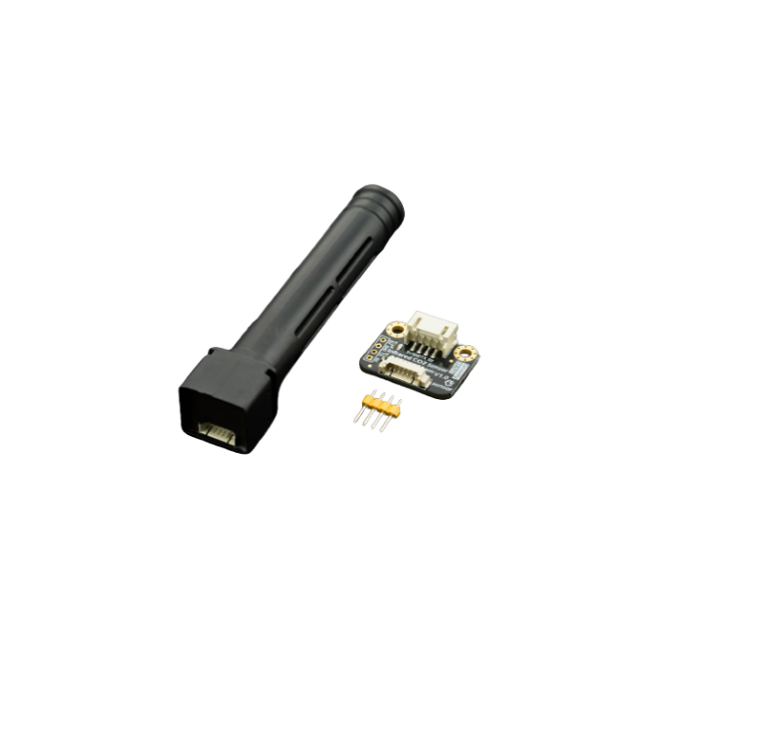

This sensor is based on non-dispersive infrared (NDIR) technology and has good

selectivity and oxygen-free dependency. It integrates temperature compensation and support UART communication mode. Most importantly, the product is easy to use; it is compatible with all types of microcontrollers with UART port, like Arduino, Raspberry Pi and other microcontrollers.

* Soil NPK sensor

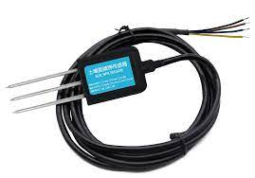

* Power supply: 5-30VDC
* Maximum power consumption: ≤0.15W
* Operating temperature: -40~80℃
* Range: 0-1999 mg/kg(mg/L)
* Resolution: 1 mg/kg(mg/L)
* Precision: ±2%FS
* Response time: ≤1S
* Protection grade: IP68
* Waterproof
  1. **Hardware Diagram**

The hardware diagram shows the various components of the circuit and how they are connected to each other. The figure given below is a hardware diagram of the project. The diagram shows the connection of PC (command feeder) to the controller (Arduino) and Arduino is connected to the two sensors

Analog Infrared CO2 sensor SEN0220

Analog pH Sensor

DS18B20 Temperature Sensor

Connector

BNC Connector

Capacitive Soil Moisture Sensor

Micro controller

PC



MAX485 TTL to RS-485 Interface Module



Soil NPK sensor



* 1. **Electrical Circuit**



**5V**

**GND**

**D I G I T A L**



**ANALOG**

Arduino

DS18B20 Temperature Sensor



4.7K OHM

**GND**

**POWER**

**SUPPLY**

**5V**

Capacitive Soil Moisture Sensor



**4.7k ohm**



Analog pH Sensor



BNC Connector



**2.4 Output and IOT Diagram**



**12V**



Soil npk sensor



Analog Infrared CO2 sensor SEN0220

Connector

MAX485 TTL to RS-485 Interface Module

The diagram shows the various components of the circuit and how they are connected to each other. Signal is sent by Arduino to vacillate sensors to perform action then sent output to IOT System

Analog Infrared CO2 sensor SEN0220

Analog pH Sensor

DS18B20 Temperature Sensor

Connector

BNC Connector

Capacitive Soil Moisture Sensor

Micro controller

PC

**input**



**input**



**output**



**input**



**input**



**OUTUP BY SENSORS**



**output**



IOT analytics: (ThingSpeak)



**input**



MAX485 TTL to RS-485 Interface Module



Soil NPK sensor

**output**



**CHAPTER 3**

**PROGRAMMING AND IOT INTERACTION**